 | Name: Last Name:  Subject:  Cohort: Classroom:

Grade/100 | Introduction to management  Final Exam  Professor Name: Salma Mahouachi  Fall 2023  Date:  Friday, December 15th  Time:  14.00-16.00  Classroom visit:  14.00-16.00 | Supervisors Signature

INSTRUCTIONS

- Books and notes allowed.
- Cell phones allowed.
- Calculators allowed.

Statement of Academic Integrity

Statement on Academic Integrity
I pledge to pursue all academic endeavors while at MedTech with honor and integrity. I understand the principles of the MedTech Honor Code, and I promise to uphold and respect them. I pledge not to ask for or give information pertaining to any examination before or after I have taken it, in such a way as to gain or give an advantage to one student over another. I understand to be honor code violation: The giving and/or receiving of unauthorized aid on a paper, problem, homework, exam, computer program, or other assignment submitted to meet course requirements; plagiarism on an assigned paper, report, exam, or other submission; failure to report a known or suspected violation of the Honor Code; any action designed to deceive a member of the faculty, staff, or a fellow student regarding the principles mentioned in the Code; the submission of work prepared for another course; the use of texts, papers, computer programs, or other class work prepared by commercial or noncommercial agents and submitted as my own work; the falsification research results; or the altering of a previously graded exam or test with the objective of having the original grade reconsidered.
Ps: All classrooms are equipped with video cameras.
Statement to be signed by the student:
I confirm that I have read and understood the statement above on academic integrity and certify that I did not commit and did not attempt to commit academic fraud in this examination.
Signed: ______________________________________
Note: an examination copy or booklet without that signed statement will not be graded and will receive an exam grade of zero.

Mini case-study: (30 points)

The youth-oriented businesses in France aren't in crisis; they're thriving. Laboratories, manufacturers, and specialized doctors form the backbone of this remarkable industry.
From cosmetic procedures by aesthetic doctors to L’Oréal's anti-wrinkle creams, these merchants of youth foresee a robust growth trajectory in the years ahead. And they have good reason for their optimism: this market is set for a prosperous future.
"Botox" Generates Impressive Profits
"It's not more expensive than a good meal at a restaurant or a couple of tanks of gas!" Dr. BEILIN shares that aesthetic medicine is becoming accessible to all. Though we're not at the stage of refilling faces like a gas station, that's the goal for anti-aging professionals. France, the second most enthusiastic country in Europe after Italy, is estimated to see nearly 407,733 aesthetic medicine procedures in 2022. Since 1991, "Botox" has been a gold mine for the leading pharmaceutical company, the American laboratory Allergan. Last year in France, thousands of individuals refreshed their appearance through facial injections, the global size was valued at USD 17.6 billion in 2022 and is expected to hit USD 36.8 billion by 2032.
This industry has become a lucrative venture! To seize this opportunity, the merchants of youth have effectively targeted their market. Their primary demographic remains French women over 35, but the landscape has expanded. Men now make up 20% of the clientele, a demographic largely overlooked a decade ago. And this is just the beginning! "It's no longer something out of reach or taboo; people from all walks of life come to see me," attests Dr. MICHAUD. His colleague, Dr. BEILIN, confirms: "Those who consult me aren't necessarily affluent. It could be a fifty-year-old seeking a career change, someone recovering from an illness, or an overlooked spouse…"
Anti-wrinkle Creams Boost Profit Margins
Eternal youth comes at a price. Cosmetic giants understand this well and sell the dream at a premium. The laboratories of the "L'Oréal Group" offer three creams, under different brands, promising to reduce wrinkles, tighten pores, and even out skin tone. They all contain the same molecule believed to combat aging skin. But when it comes to price, there's a stark difference. "Visionnaire" by Lancôme is priced at 83 euros, "Idéalia" by Vichy at 27, and "Sublimist" by L'Oréal-Paris at 12. In the cosmetics world, selling aspirations trumps comparisons based on numbers. In French perfumeries alone, 150 new products are released each year. And they come at increasingly staggering prices: 293 euros for 50 ml of Guerlain's anti-wrinkle cream, 352 euros for La Prairie's, and 450 euros for Sisley's. "For the past three years, there's been a race for the most expensive creams! Most customers believe that the higher the price, the more effective," notes the CEO of Clarins. These brands are exclusively available in reputable perfumeries (in their stores or on their websites) and major professional hair salons.

Questions:

- Specify the sector classification and the industrial classification of the activity mentioned in the text. (5points)
- What marketing segmentation criteria are used by youth-oriented businesses? (5points)
- In what stage of the product life cycle are the following products: anti-aging creams; "Botox"? Explain your answer using evidence from the text. (5points)
- What pricing strategies does the "L'Oréal Group" use for its two anti-aging creams: "Visionnaire" and "Sublimist"? Explain them and explain why there is a price difference even though they are based on the same molecule. (5points)
- Identify the market coverage distribution strategy of the brands "Guerlain," "La Prairie," and "Sisley" to market their anti-wrinkle creams. Explain. (5points)
- What sales methods are used by these brands? Provide their advantages. (5points)
Problem set: (70 points)

PART 1: "An industrial company needs to purchase a significant quantity of a product for its operations. This company has the choice between four suppliers A, B, C, and D.
The coefficients assigned to the supplier selection criteria are as follows:
Quality=3
Delivery time=2
Uncertainty=1
Proximity= 2
The details of the various offers and the criteria considered are presented in the following table:

Providers | Price | Quality | Delivery time | Uncertainty | Proximity
A | 80 | Good | 50j | Exceeding 40% | Aboard
B | 100 | Very good | 60j | Exceeding 20% | Immediate
C | 90 | Average | 40j | Consistent | Regional
D | 80 | Below average | 90j | Over 50% | Nearby

  - Which provider should the company choose? (10 points)

PART 2: A production project of the company is presented as follows:
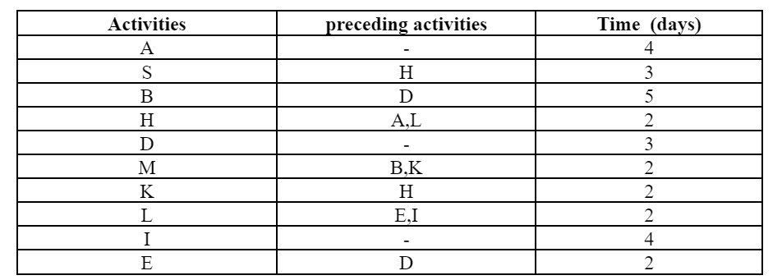
  - Represent the PERT chart (10 points)
  - Identify the critical path and explain what it is (10 points)
  - What will be the project completion date if the duration of task H becomes 5 days (10 points)

PART 3: The accounting management of the company presents the following data as of 31/12/2023:
Unit selling price: 50D
Raw materials: 10D per unit
workforce: 12D per unit
Insurance: 3,000D
Depreciation and provisions: 35,000D
Electricity expenses: 4,000D
Rent: 5,000D

  - Determine the fixed costs and variable costs. (10 points)
  - Determine the break-even point in quantity and value. (10 points)
  - Determine the impact of a 5% increase in the overall variable cost? (10 points)

END
Good Luck

